1. Header and source code are stored under name three_a.h/.c

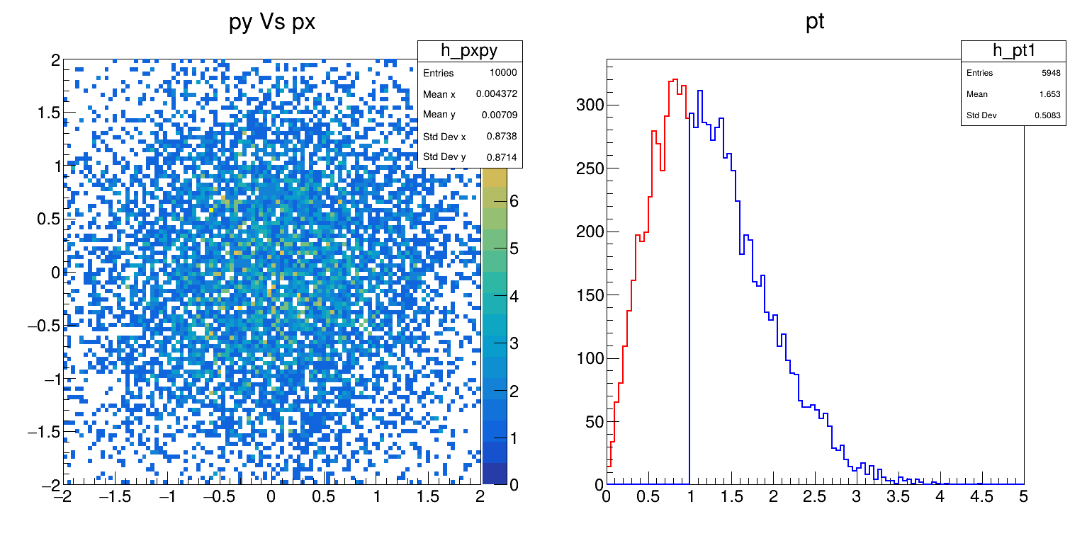

1. Header and source code are stored under name three_b.h/.c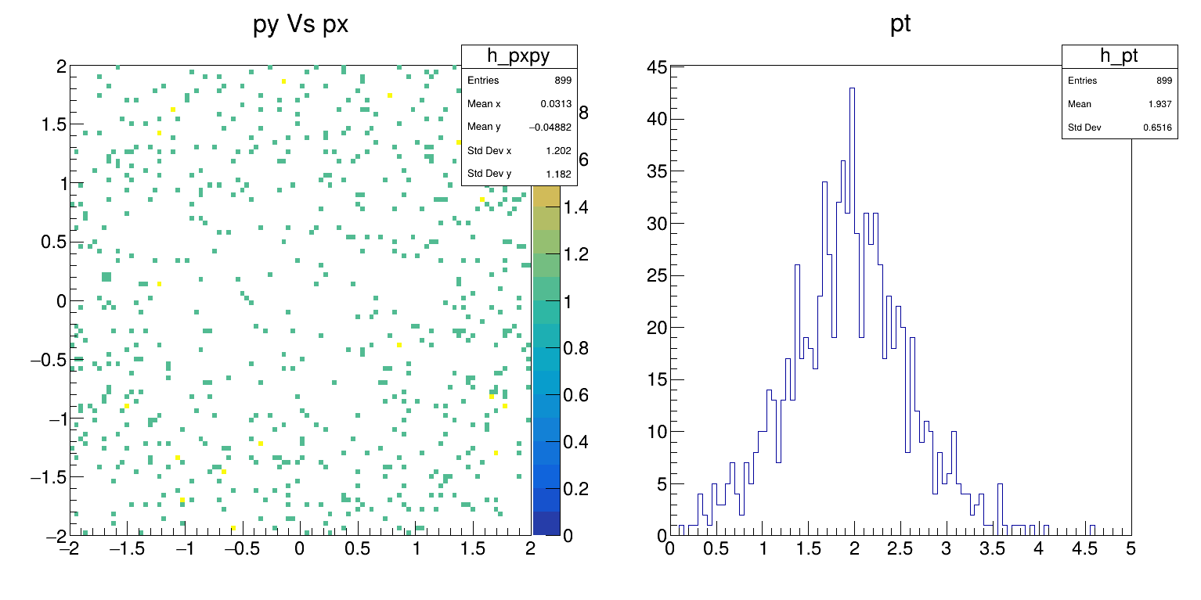
2. Header and source code are stored under name three_c.h/.c

